28.10.2021

# Mini hydel:

1. **TCODE : ZAGMT01 - Critical**

Recoveries Tab is not Provided. Rebate & Reactive Tabs are required in the Recoveries Tab. The formats are same as Solar.

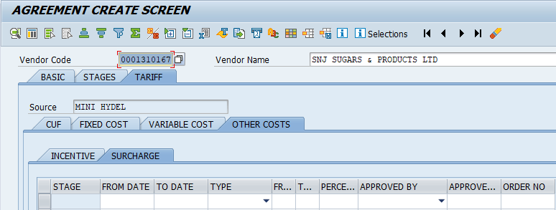

1. **TCODE : ZAGMT01 – Critical**

Surcharge Screen is also to be changed as per Remarks of 27.10.2021

1. **TCODE : ZAGMT01 – Critical**

Royalty Charges are applicable for the Mini hydel Projects. In this regard, the following fields are required in the Basic Tab :

1. Royalty Charges Applicable – Yes/No
2. Royalty Rate / KWh – (2,3). This field should enable only if the above option is selected as YES.
3. Special Case – Balaji Energy Private Limited & Khandaleru Project to be discussed.

# Industrial Waste / Biomass :

1. **TCODE : ZAGMT01 – Critical**

Surcharge, Rebate and Reactive Screens are to be developed. The Screens are same as Solar.

1. **TCODE : ZAGMT01 – Low**

CUF is to be replaced with PLF for Bagasse, Biomass, Mini hydel & Industrial Waste Projects. Except Name Change, the remaining calculations are same.

